Copulas: USDCHF and EURGBP
Method 18 / daily log returns / empirical ranks / Gaussian + Clayton / Alpari D1 full available history

Study setup
Logical pair: USDCHF , EURGBP
Broker symbols: USDCHF_i , EURGBP_i
Snapshot: 2026-11-03_majors_alpari_D1
Timeframe: D1
Matched return window: 1999-01-06 to 2026-11-02 (UTC bar dates)
Matched return count n: 7182
Dropped unfinished last bar dated 2026-11-03 UTC after a tick-volume check against the prior complete day.
Margins: empirical ranks / (n+1)
Families: Gaussian (rho) and Clayton (theta), fixed before ranking
Complete matched rows (Excel): USDCHF-EURGBP_Copula_D1.xlsx
Complete matched rows (HTML table): USDCHF-EURGBP_Copula_D1_data.html

Method carried forward
Copulas separate marginal return shapes from dependence on the unit square. Matched daily log returns of close, ln(close_t / close_t-1), are mapped to pseudo-observations u_i = rank(x_i)/(n+1) and v_i = rank(y_i)/(n+1). A Gaussian copula parameter rho is the Pearson correlation of Phi^{-1}(u) and Phi^{-1}(v). A Clayton copula theta >= 0 is fit by maximum likelihood on (u,v) for lower-tail asymmetry. Quotes are not inverted. Kendall tau implied by each fit and Spearman of (u,v) are stored. Same-sample Pearson r on returns is a side check. This is not causation and not a trading signal.

Results
Gaussian rho: -0.369763
Gaussian Kendall tau: -0.241122
Clayton theta: 0.000000
Clayton Kendall tau: 0.000000
Spearman of (u,v): -0.347712
Pearson r on returns: -0.325886

Conclusion
Over 7182 matched daily rows for USDCHF and EURGBP, Gaussian copula rho = -0.3698 (Kendall=-0.2411) and Clayton theta = 0.0000 (Kendall=0.0000). Spearman of (u,v) = -0.3477; Pearson r on returns = -0.3259. This is not causation and not a trading signal.

Charts
Daily closes

Daily log returns

Pseudo-observations (u,v)
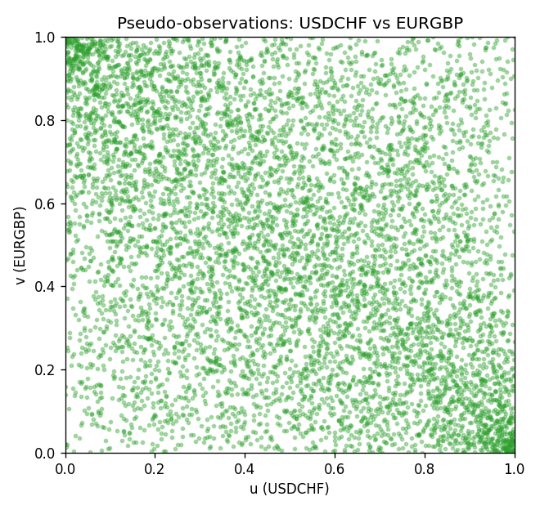

Data report
Every matched row is stored in the sibling Excel workbook named USDCHF-EURGBP_Copula_D1.xlsx, including u and v. Embedding all rows as a Word table is impractical; this file holds column summaries and the first and last 15 matched rows.
Columns: time, USDCHF_open, EURGBP_open, USDCHF_high, EURGBP_high, USDCHF_low, EURGBP_low, USDCHF_close, EURGBP_close, USDCHF_tick_volume, EURGBP_tick_volume, USDCHF_spread, EURGBP_spread, USDCHF_real_volume, EURGBP_real_volume, USDCHF_log_return, EURGBP_log_return, u, v
Column summaries (matched calculation rows)
column | count | mean | std | min | 25% | 50% | 75% | max
USDCHF_open | 7182 | 1.0972493 | 0.25210985 | 0.72022 | 0.9204925 | 0.989875 | 1.237175 | 1.8219
EURGBP_open | 7182 | 0.7869939 | 0.09664695 | 0.5734 | 0.6877 | 0.833905 | 0.865225 | 0.9769
USDCHF_high | 7182 | 1.1025378 | 0.25385182 | 0.73305 | 0.924695 | 0.99351 | 1.242175 | 1.8313
EURGBP_high | 7182 | 0.79007306 | 0.09702085 | 0.5789 | 0.6897 | 0.836955 | 0.8681 | 0.9799
USDCHF_low | 7182 | 1.092133 | 0.25052689 | 0.08565 | 0.9171825 | 0.986205 | 1.2312 | 1.8121
EURGBP_low | 7182 | 0.7842938 | 0.09646529 | 0.5682 | 0.685725 | 0.83166 | 0.86287 | 0.9661
USDCHF_close | 7182 | 1.09724 | 0.25200902 | 0.72025 | 0.9207375 | 0.98991 | 1.23715 | 1.8217
EURGBP_close | 7182 | 0.78703952 | 0.09664503 | 0.5735 | 0.687825 | 0.83398 | 0.865375 | 0.977
USDCHF_tick_volume | 7182 | 74362.695 | 113509.88 | 18 | 12814.25 | 40258.5 | 70446 | 858589
EURGBP_tick_volume | 7182 | 87145.49 | 145506.26 | 154 | 6593.75 | 44371 | 81432 | 1424684
USDCHF_spread | 7182 | 26.020746 | 24.692144 | 0 | 5 | 16 | 50 | 100
EURGBP_spread | 7182 | 21.320663 | 19.117614 | 0 | 4 | 13 | 40 | 50
USDCHF_real_volume | 7182 | 2.3303821e+10 | 8.915094e+10 | 0 | 0 | 0 | 0 | 1.9331921e+12
EURGBP_real_volume | 7182 | 2.7876168e+10 | 1.3522356e+11 | 0 | 0 | 0 | 0 | 3.5726265e+12
USDCHF_log_return | 7182 | -7.199e-05 | 0.00659004 | -0.19545699 | -0.00335239 | 7.626e-05 | 0.00331734 | 0.09051364
EURGBP_log_return | 7182 | 2.529e-05 | 0.00487429 | -0.03067367 | -0.00262165 | -0.00010006 | 0.00256425 | 0.06075387
u | 7182 | 0.5 | 0.28865503 | 0.00013922 | 0.25006961 | 0.5 | 0.74993039 | 0.99986078
v | 7182 | 0.5 | 0.28865499 | 0.00013922 | 0.25006961 | 0.5 | 0.74993039 | 0.99986078
First 15 matched rows (selected columns)
time | USDCHF_log_return | EURGBP_log_return | u | v
1999-01-06 | 0.013605652 | -0.013303338 | 0.98385076 | 0.0080746206
1999-01-07 | -0.0093883841 | 0.011051402 | 0.058610608 | 0.98218015
1999-01-08 | 0.011040268 | -0.004943862 | 0.96700543 | 0.11917026
1999-01-11 | 0.0052963193 | -0.0012752393 | 0.84505081 | 0.37435612
1999-01-12 | -0.0098275602 | 0.0033970309 | 0.052485034 | 0.80161492
1999-01-13 | -0.018259701 | 0.00042381861 | 0.0058471391 | 0.55032716
1999-01-14 | -0.0024256692 | -0.0019793588 | 0.30502576 | 0.30781011
1999-01-15 | 0.01794228 | -0.0076715819 | 0.99498817 | 0.048726159
1999-01-18 | -0.0031856384 | 0.00071280921 | 0.25908395 | 0.58039816
1999-01-19 | -7.2518946e-05 | -0.0014261269 | 0.4865655 | 0.36113045
1999-01-20 | 0.0072259871 | 0.0019960086 | 0.90783795 | 0.70597243
1999-01-21 | -0.0038232689 | -0.00071240297 | 0.22678547 | 0.43185299
1999-01-22 | -0.0001445609 | -0.0017118406 | 0.48016149 | 0.33133788
1999-01-25 | 0.0024546976 | -0.0054402425 | 0.69121537 | 0.10135041
1999-01-26 | 0.0020889617 | -0.00057438255 | 0.66420716 | 0.44883753
Last 15 matched rows (selected columns)
time | USDCHF_log_return | EURGBP_log_return | u | v
2026-10-13 | -0.0024955621 | 0.00020130374 | 0.30015314 | 0.53069748
2026-10-14 | 0.0029388325 | 0.0011241873 | 0.72518446 | 0.62313796
2026-10-15 | -0.0097855323 | -0.00087557391 | 0.053459557 | 0.41250174
2026-10-16 | -0.0036230826 | -0.0020380844 | 0.23820131 | 0.30265906
2026-10-19 | 0.0036351779 | -0.00056950988 | 0.76806348 | 0.44953362
2026-10-20 | -0.0026281224 | -0.0035906254 | 0.29207852 | 0.18571627
2026-10-21 | -0.00040027413 | -0.00140647 | 0.45621607 | 0.36252262
2026-10-22 | -0.0048036381 | -0.0018743924 | 0.18390645 | 0.31672003
2026-10-23 | 0.005652514 | 0.00082421033 | 0.86022553 | 0.59209244
2026-10-26 | 0.0018407959 | 0.00013133309 | 0.64346373 | 0.52206599
2026-10-27 | 0.0026100526 | -0.0019957343 | 0.7009606 | 0.30655715
2026-10-28 | -0.0010142111 | 0.00066967224 | 0.40818599 | 0.57719616
2026-10-29 | -0.0048680164 | -0.0011722209 | 0.18084366 | 0.38382292
2026-10-30 | 0.00071594559 | -0.0024205543 | 0.55422525 | 0.26771544
2026-11-02 | -0.0071459744 | 0.00089940465 | 0.10274259 | 0.6004455

